
Survey

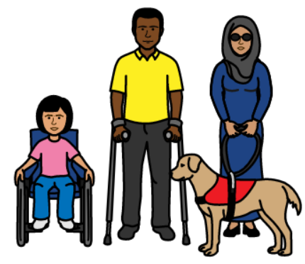
Disability Access and Inclusion Plan

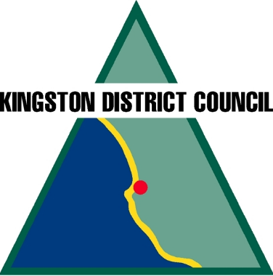
Kingston council area


Easy English

We are making a Disability Access and Inclusion Plan.


We will call this The Plan from now on.


The Plan will help make the community better.

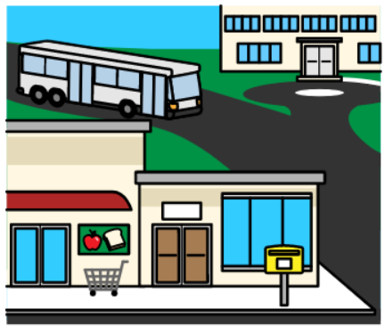
It will help people with disability
- have better access to the community
and
- be more included in the community.

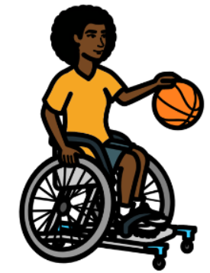
What does it mean to have access?
Accessing the community can mean many different things. It can mean
- getting to and from places
- communication and information that you understand
- feeling comfortable, welcome and safe
- being able to do things that people without disabilities can do.

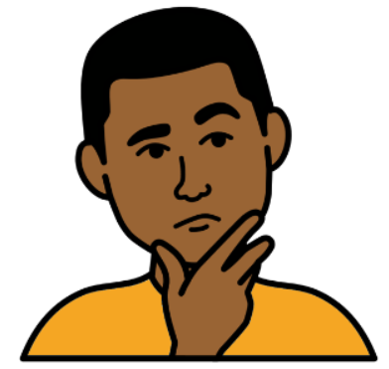
We want to know what will make your local community better.

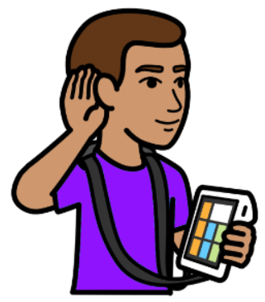
We want to hear what you have to say.
Please fill in the survey.

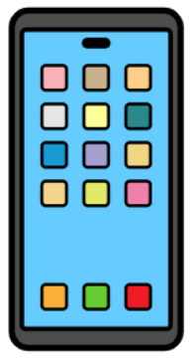
If you need help with the survey, you can
Phone Allison Semmler 08 8767 2033
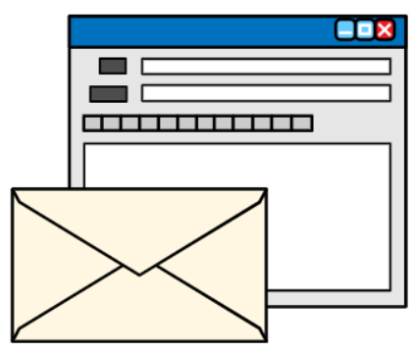
or
Email asemmler@kingstondc.sa.gov.au

Survey
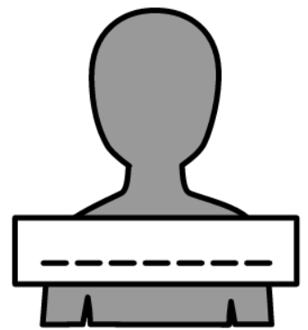
What is your name? You do not have to tell us if you do not want to.
____________________________________________

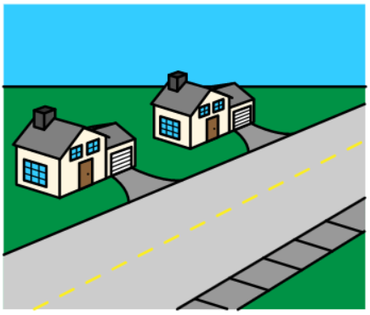
What is your postcode? ___________

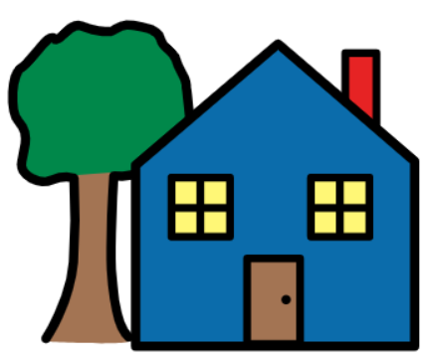
Do you live, visit or work in the Kingston council area?
☐I live there
☐I visit there
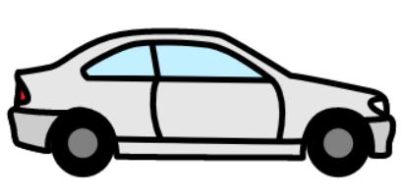
☐I work there
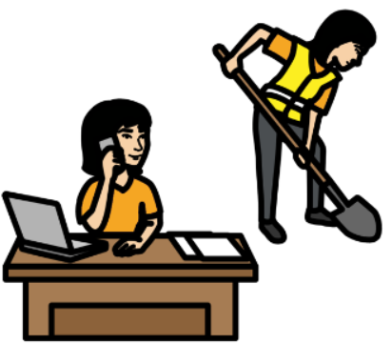
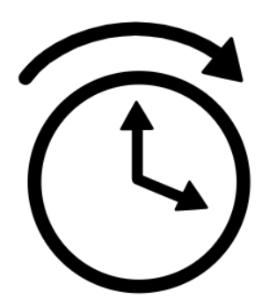
Do you live in the Kingston council area most of the time or only some of the time?
☐I live there most of the time
☐I live there only some of the time
☐I do not live in the Kingston council area

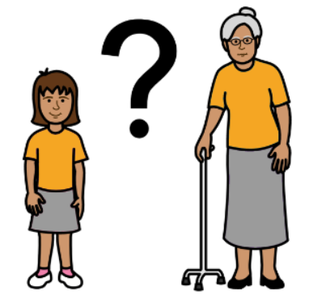
What is your age?
☐Under 18
☐18 to 24
☐25 to 34
☐35 to 44
☐45 to 54
☐55 to 64
☐65 to 74
☐75 to 84
☐Over 85
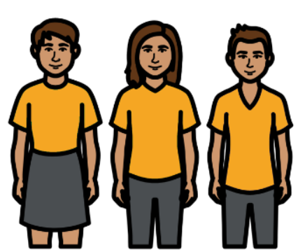
What is your gender?
☐Female
☐Male
☐Non-binary
☐Other
☐I do not want to say

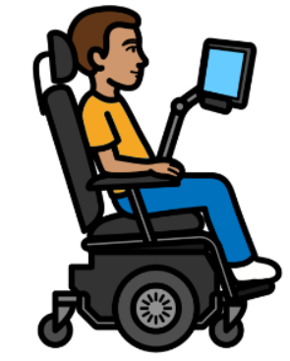
Please tick the box that applies to you. You can tick more than 1 box.
☐I have a disability
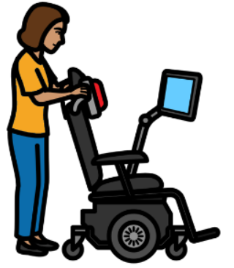
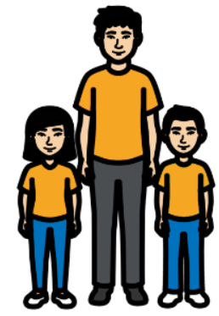
☐I am a family member, loved one, or carer to a person with disability
☐I work in the disability sector
☐I work for the local government
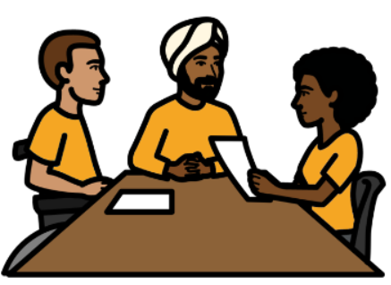
What is your disability? You do not have to tell us if you do not want to. You can tick more than 1 box.
☐Intellectual disability
☐Autism Spectrum Disorder
☐Physical disability
☐Neurological disability
☐Brain injury
☐Blind or low vision
☐Deaf or hard of hearing
☐Deafblind
☐Mental health disorder
☐Neurodivergent
☐Chronically ill
☐My disability is not on this list
☐I do not want to say
☐I do not have a disability
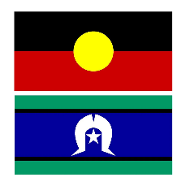
Please tick the box if any of these apply to you. You can tick more than 1 box.
☐I am an Aboriginal and/or Torres Strait Islander person
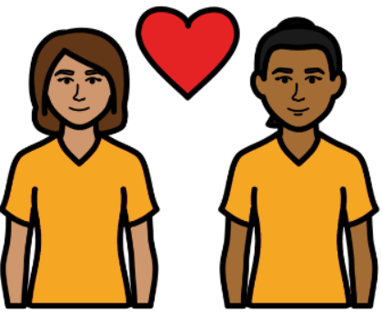
☐I am from the LGBTQIA+ community
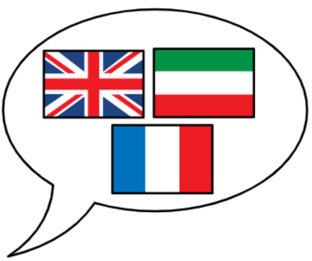

☐I speak a language other than English
☐I am not from Australia
☐I live far from the city
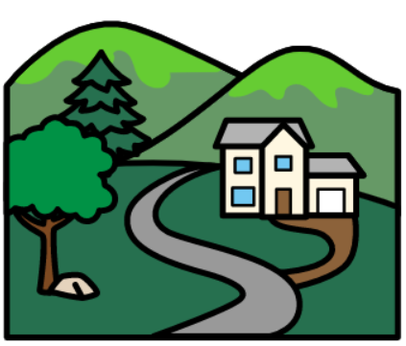

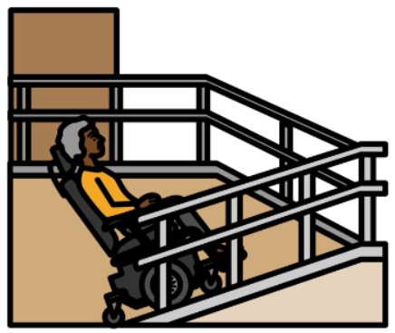
Do you think people with disability can access your local community?
☐It is very hard to access
☐It is a bit hard to access
☐It is just okay to access
☐It is sort of easy to access
☐It is very easy to access
☐I am not sure

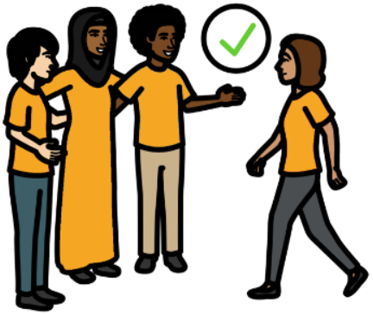
Do you think people with disability are included in your local community?
☐They are never included
☐They are not usually included
☐They are sometimes included
☐They are included most of the time
☐They are included all the time
☐I am not sure

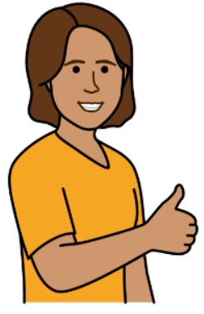
What are some good things your local community is doing to
- make it easier for people with disability to access
and/or
- include more people with disability?
You do not have to say if you do not want to.
________________________________________________________________________________________________________________________________________________________________________________________________________________________________________________________________________________________________________________________________________________________________________________________________________________________________________________________________________________________________________________________________________________
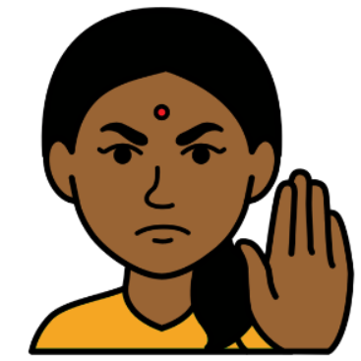
What is the biggest thing stopping people with disability from being part of your local community?
You do not have to say if you do not want to.
____________________________________________________________________________________________________________________________________________________________________________________________________________________________________________________________________________________________________________________________________________________________________________________________________________________________________________________________________________________________________

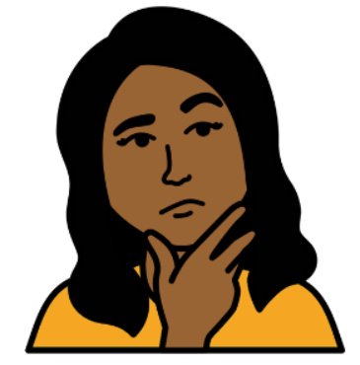
Is there anything else your local community could do to
- make it easy to access for people with disability
and/or
- include more people with disability?

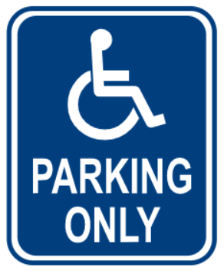
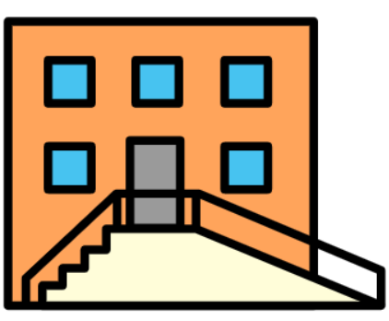
This could be things like
- making buildings better
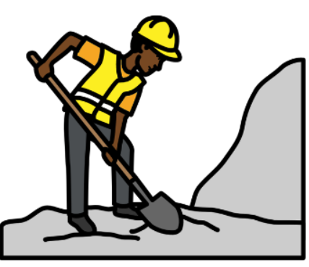
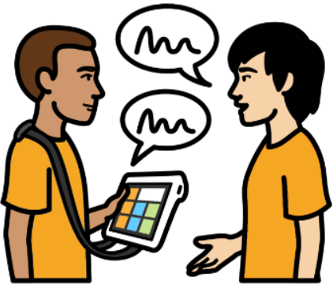
- having more signs
- teaching others about disability
- making work better for people with disability
You do not have to say if you do not want to.
____________________________________________________________________________________________________________________________________________________________________________________________________________________________________________________________________________________________________________________________________________________________________________________________________________________________________________________________________________________________________

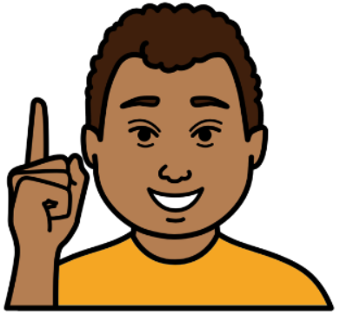
Is there anything else you want to add about helping people with disability
- access your community better
and/or
- be more included in your community?
________________________________________________________________________________________________________________________________________________________________________________________________________________________________________________________________________
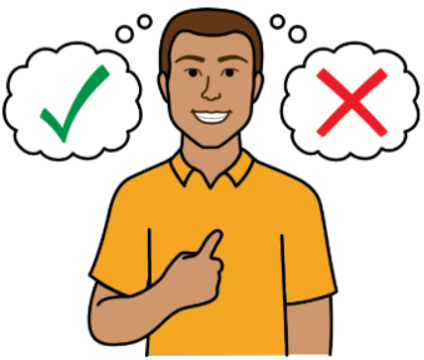
Would you like to know more about The Plan?
If yes, please write your name and email here.
Your name:___________________________________
Your email:___________________________________

After you have finished the survey, you can:
Email it to: asemmler@kingstondc.sa.gov.au
Or
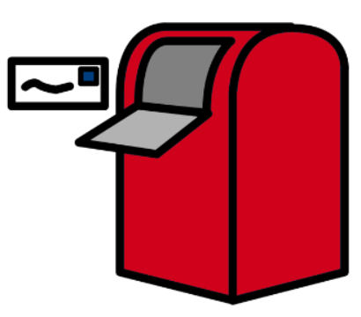
Print it out and post it to: Kingston District Council PO Box 321 Kingston SE SA 5275


Thank you for your time!

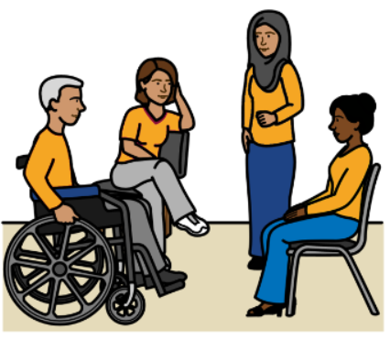
What’s next?
There will be a community workshop on Wednesday, 3rd December 2025.

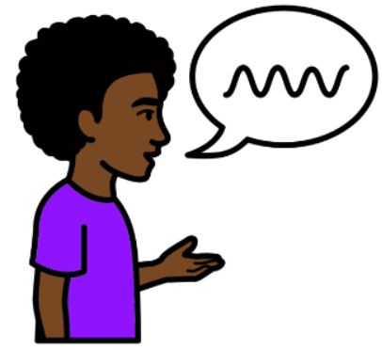
We will talk more about The Plan.

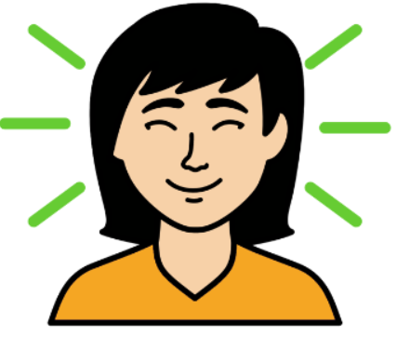
You are welcome to join.
You can find out more information here.

We are doing another survey in early 2026.

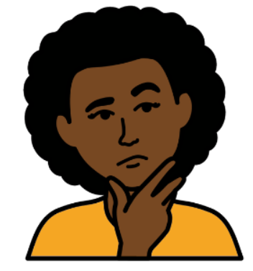
You can have your say on what you think about The Plan so far.

